
The University of Azad Jammu and Kashmir Muzaffarabad
Name :Jawahir Ali Roll No: 2024-SE-34 Course: CA&LD
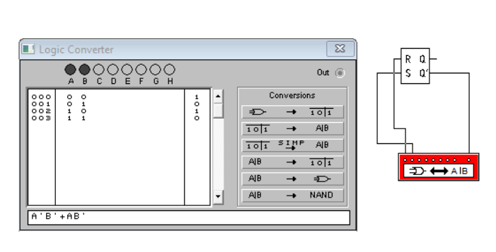
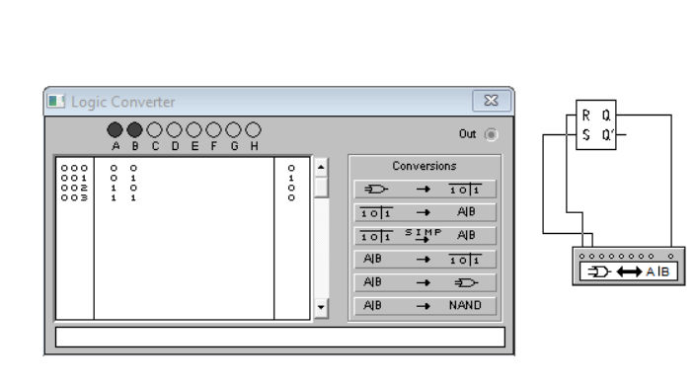
- SR-Latch

